

**本科实验报告**

|  |  |
| --- | --- |
| 课程名称： | 计算机体系结构 |
| 姓 名： | 周炜 |
| 学 院： | 计算机科学与技术学院 |
| 系： | 计算机科学与技术系 |
| 专 业： | 计算机科学与技术 |
| 学 号： | 3210103790 |
| 指导教师： | 卜凯 |

2023年 12 月 11 日

Lab 6: Dynamically Scheduled Pipelines using Scoreboarding

周炜 3210103790

1. **Purpose**

Redesign the pipelines with **IF/IS/RO/FU/WB** stages and supporting multicycle operations and design of a **scoreboard** and integrate it to CPU.

* Understand the principle of piplines that support multicycle operations.
* Understand the principle of Dynamic Scheduling With a Scoreboard.
* Master the design methods of piplines that support multicycle operations.
* Master the design methods of Dynamically Scheduled Pipelines using Scoreboarding.
* Master verification methods of Dynamically Scheduled Pipelines using Scoreboarding.

1. **Task**

* Redesign the pipelines with IF/IS/RO/FU/WB stages and supporting multicycle operations.
* Design of a scoreboard and integrate it to CPU.
* Verify the Pipelined CPU with program and observe the execution of program.

This experiment will be conducted using the SWORD development board featuring the XC7K325TFFG676-2L FPGA. We have been provided with a Verilog project that complements a CPU core and various components for debugging purposes on the board. This CPU should have the capability to handle both integer and floating-point operations. While most of the components have already been completed, there remains one unit that requires our attention, which is the **CtrlUnit.v**:

1. **Experimental process**
   1. **CPU Architecture**

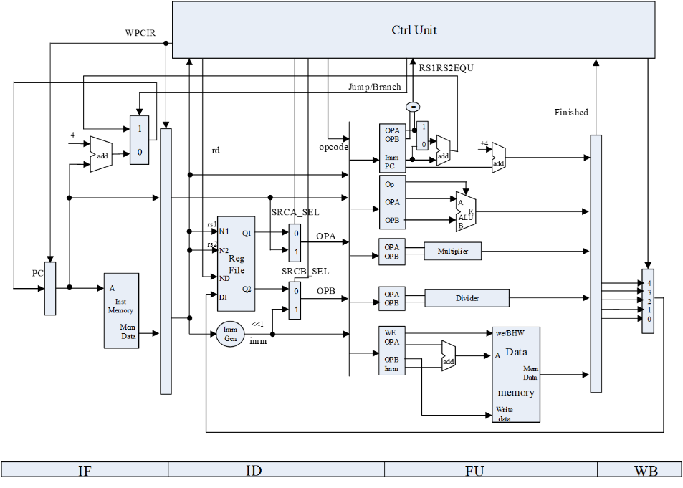

**IF阶段**

Here shows the specific content of each pipeline stage, this part of the gap is not too big with the experiment five, we can view on their own, I will not show in detail (and then look at each pipeline stage and experiment 5 is not much difference)

|  |  |
| --- | --- |
|  |  |

**IS阶段**

The IS phase differences are also minor, although in lab5 the IS phase is called ID

|  |  |
| --- | --- |
|  |  |

**RO阶段**

RO stage read operand

|  |  |
| --- | --- |
|  |  |

**FU阶段**

Perform specific floating point calculations

|  |  |
| --- | --- |
|  |  |

**WB阶段**

Writing back to the stage doesn't make much difference

|  |  |
| --- | --- |
|  |  |

* 1. **ScoreBoard Structure**

**Instruction Status**

Since there is no corresponding component to be added, but rather the result of the implementation, there is no need to consider the

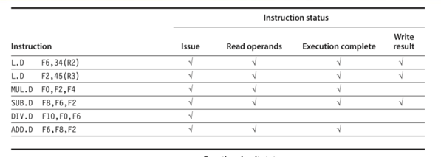

**Function Unit Status (FUS)**

First look at the Function Unit Status, record the status of the Function unit

This experiment adds the field **FU_DONE** on top of the original 9 fields to record whether the instruction is executed or not.

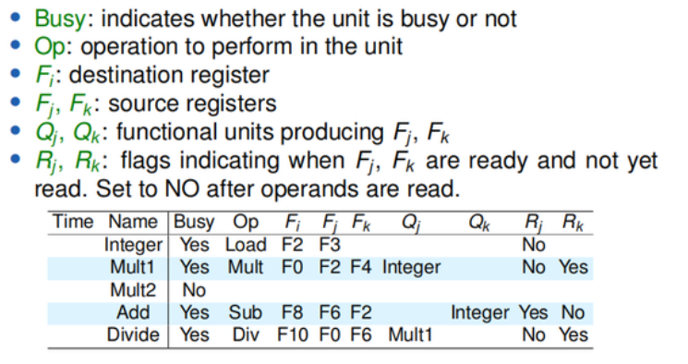

In our experiments, we assign a 32-bit register to each functional unit to record a series of corresponding states, with 1:5 indicating which function unit, while the 32 bits indicate the information stored in the FUS, e.g., bit 0 is Busy, and 1-5 record the operands (in the following two examples, the first one refers to the source operand of the instruction that uses the memory module (In the following two examples, the first one is the source operand 1 of the instruction using the memory module, and the second one is the source operand 2 of the instruction using the division module).

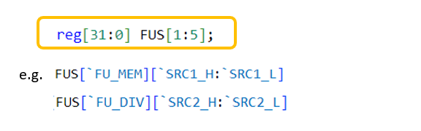

The specific macros are defined as

|  |  |
| --- | --- |
|  |  |

**Register Result Status (RRS)**

The second is the Register Result Status table, which records which Function unit will write to the registers.

There are 32 registers in total, and the value of each one may correspond to one of the function units on the right.

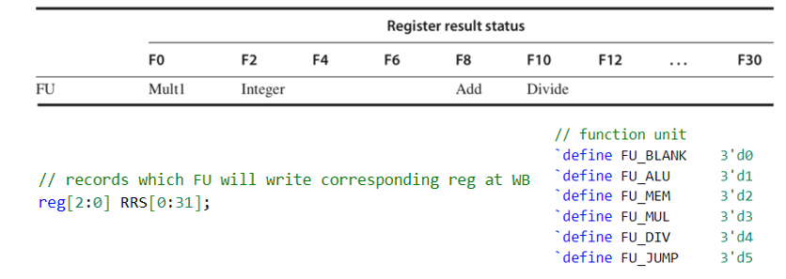

* 1. **ScoreBoard Process**

The main focus of this experiment is to implement the ScoreBoard algorithm in **CtrlUnit.v**. There is no remaining code to add.

There are two main things we need to do with our code, one is to update and maintain the scoreboard, and the other is to control the pipeline according to the current state of each of them.

At this point, if the functional component corresponding to the instruction is idle and the instruction does not have a WAW (write after write) adventure, it can be launched

**IS阶段**

normal_stall detects strcural hazard to see if there are any free functional parts and WAW adventures, and then there will be some control hazard logic here, if you encounter a branch type of instruction, it will be stalled The latter instruction will wait until the **branch has finished executing before it can be issue**

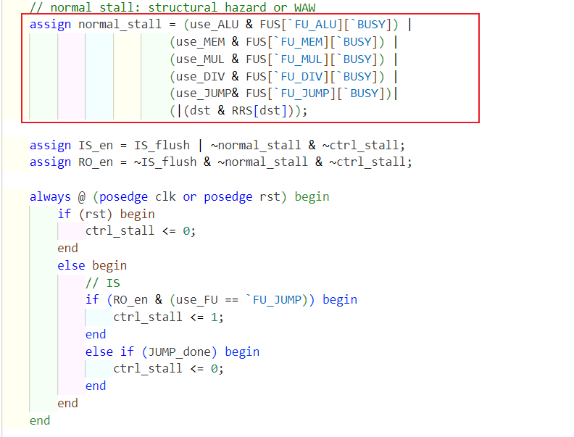

FUS and RRS will be set up inside the code if it can be issue

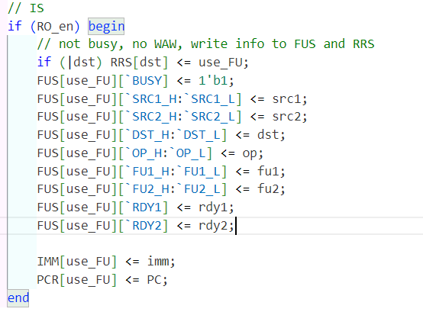

**Read Operands阶段**

Before operating, you need to know which register values are required for the current instruction, whether the value is ready or not, and if the value is not ready, which function part the value is being operated on.

At this point if the values are not ready **(RAW adventure)** then the instruction cannot read the data. If the registers are all ready to be read, then the corresponding register values are stored in the operand register (the RDY bit is reset to 0 at this point).

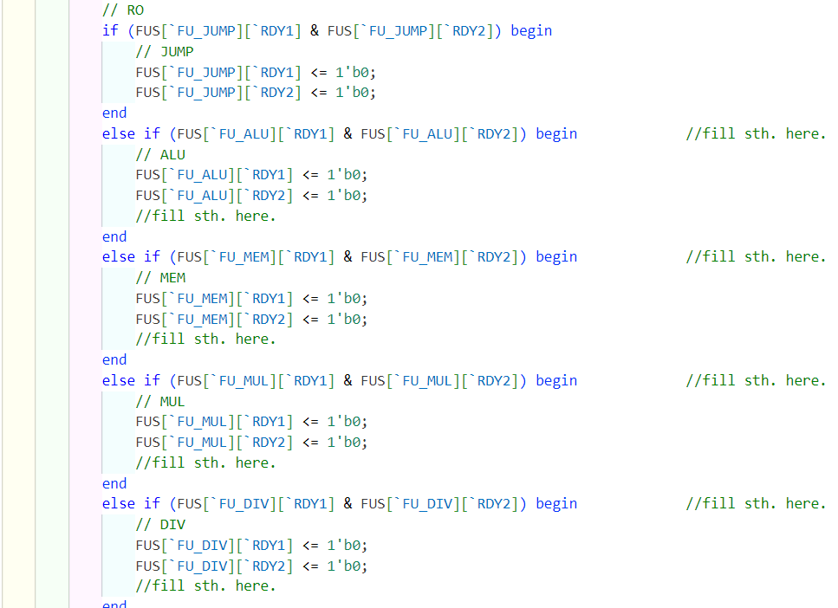

**EX阶段**

Tracks whether the function unit corresponding to each floating-point operation module has finished executing, and sets FU_DONE if it has.

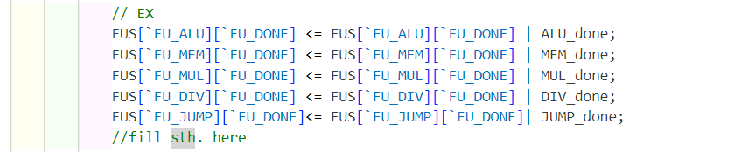

**WB阶段**

After the execution is finished to write back, write back to pay attention to the **WAR adventure**, you need to observe all the Rj, Rk, if the relevant register RDY is 1, then it means that there is an instruction to read the current register to be written to the value of the register before being written, then you have to wait for the prequel instruction to read the register before writing back. If there is no WAR adventure, then you can write back to the registers

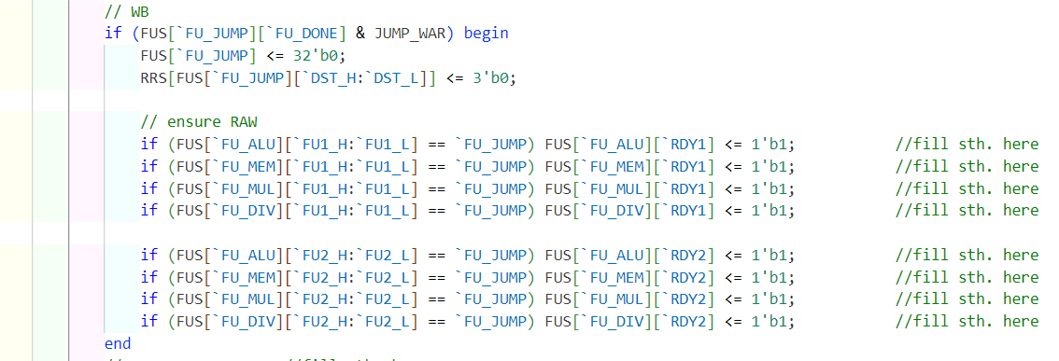

Then look inside the FUS to see if there are any other instructions waiting for their value and set them to Ready. then clean up the FUS and RRS and the instruction is done. The following is to set RDY for each FU register.

ALU

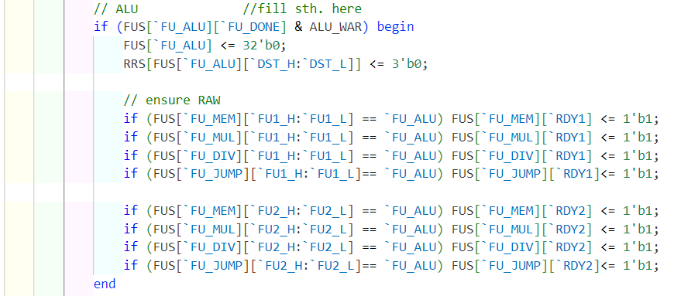

MEM

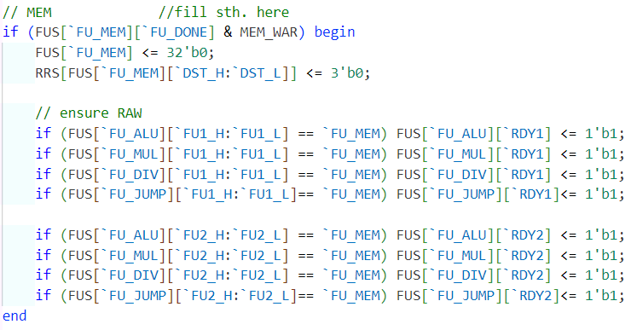

MUL

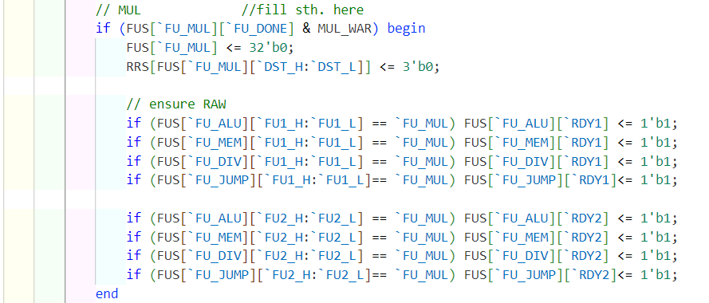

DIV

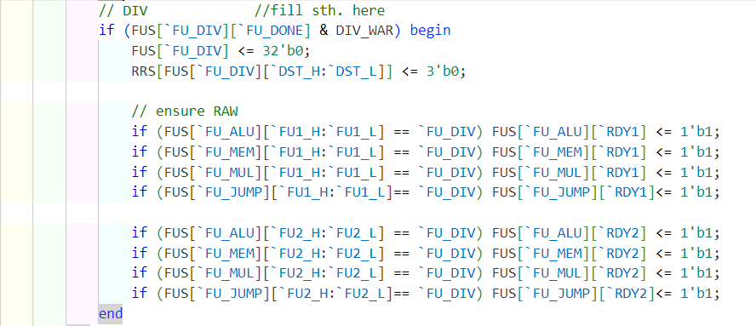

1. **Result and Analysis** 
   1. **Simulation results**

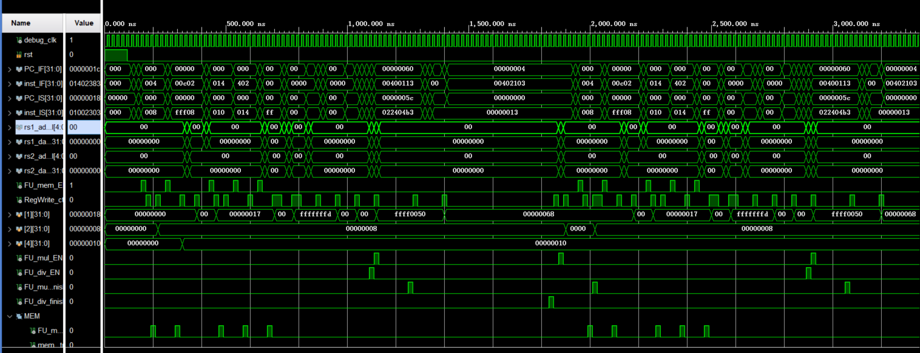

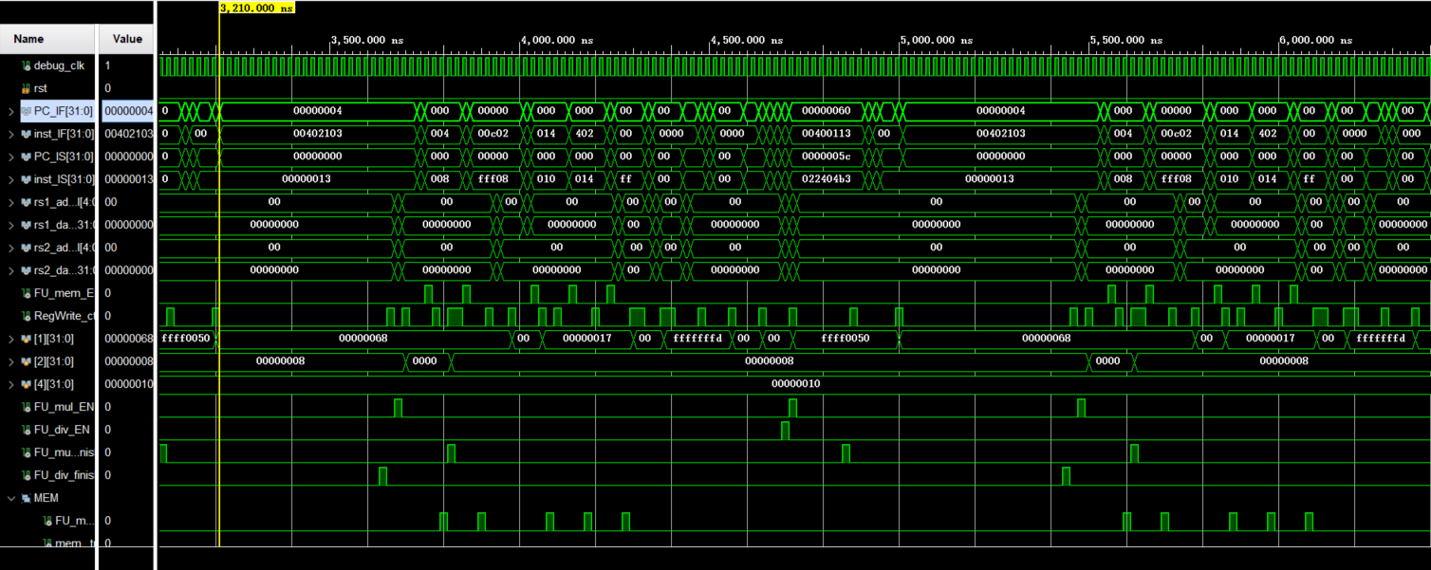

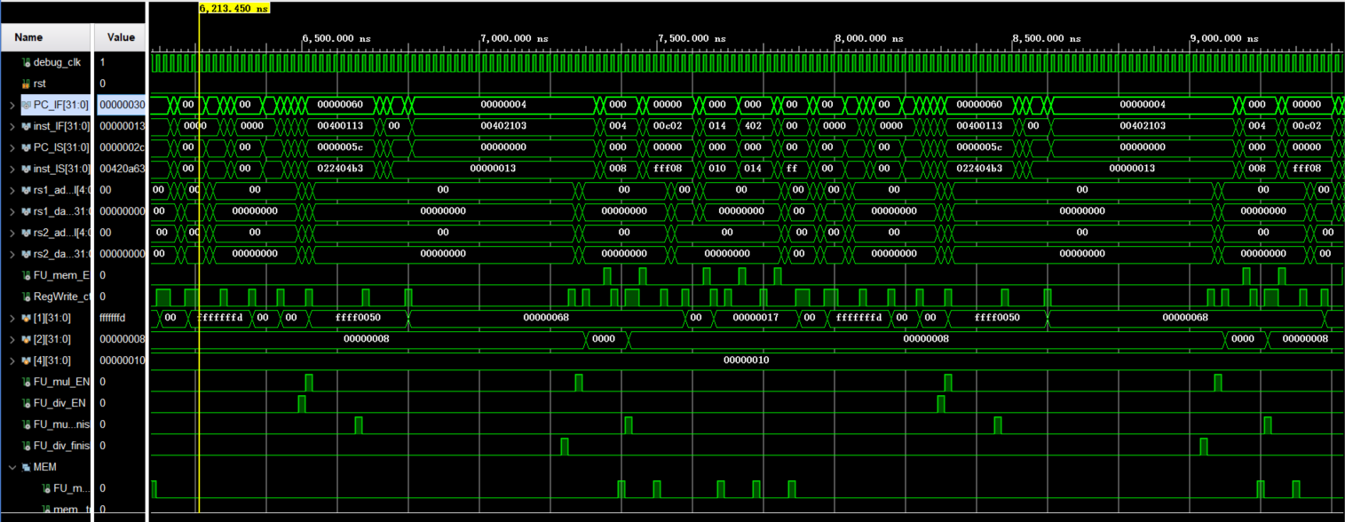

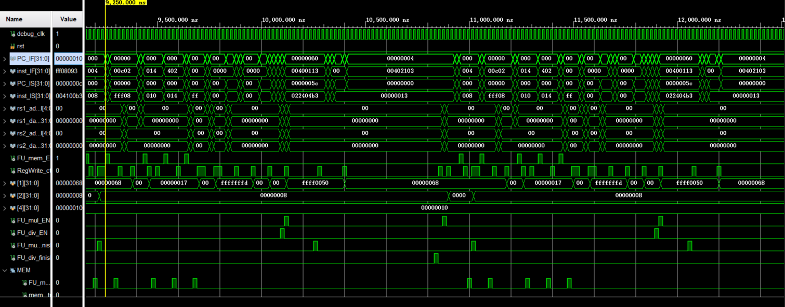

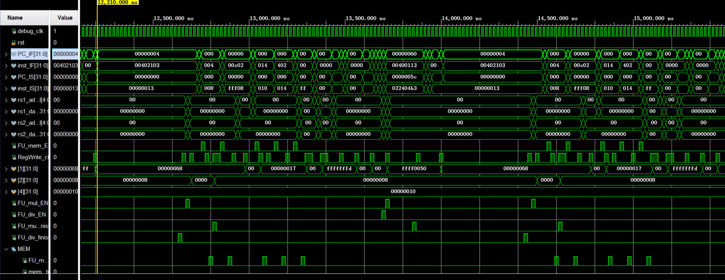

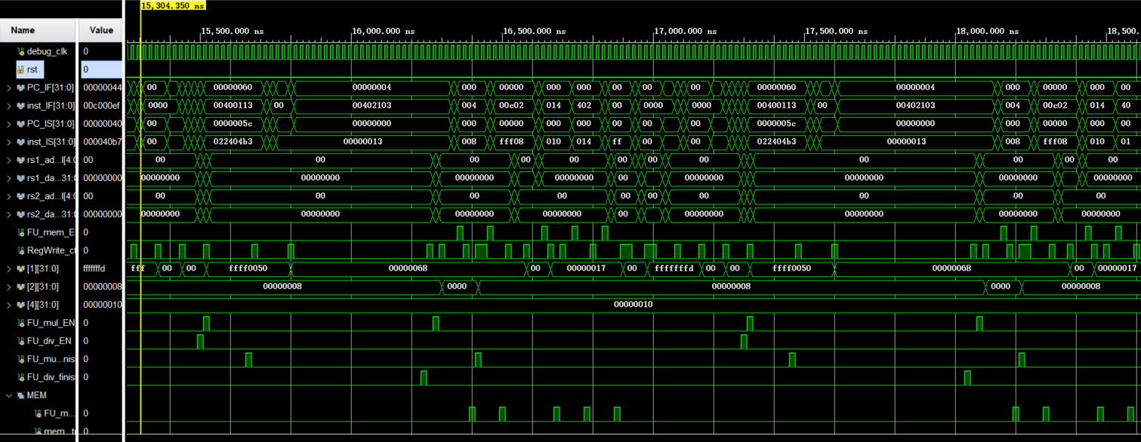

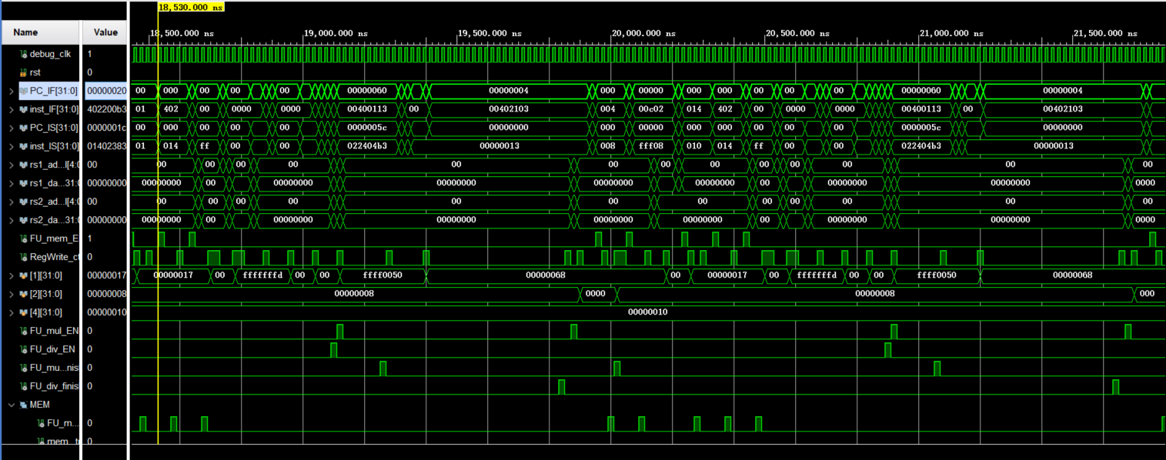

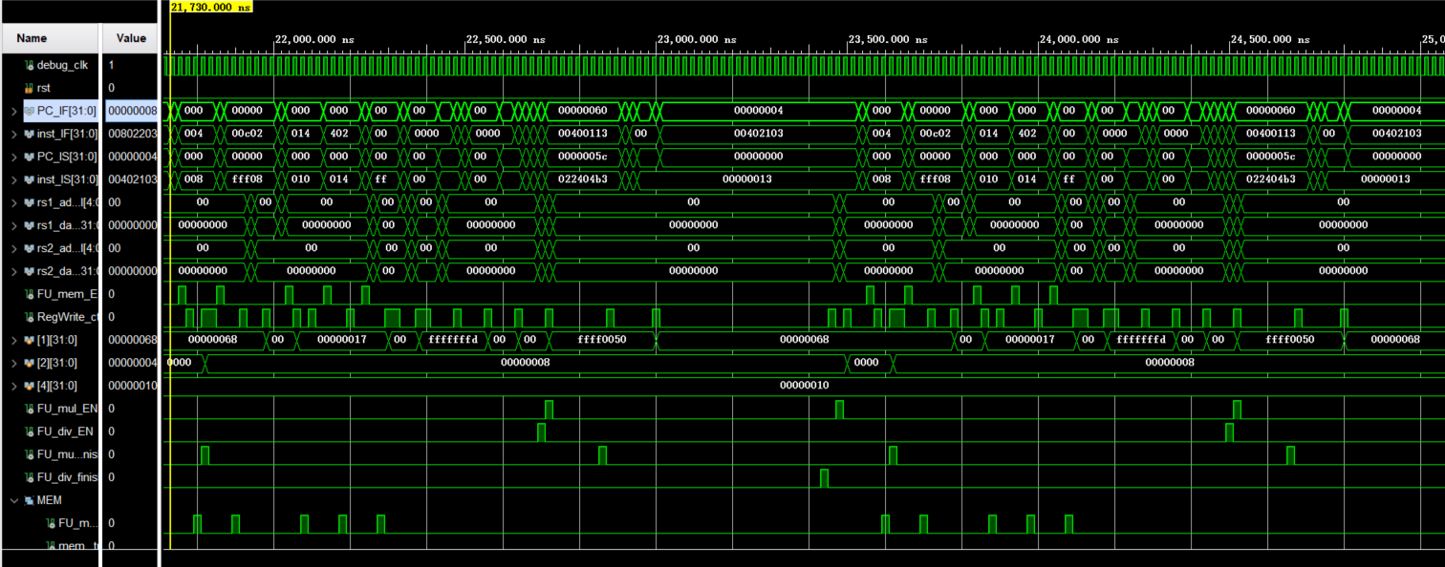

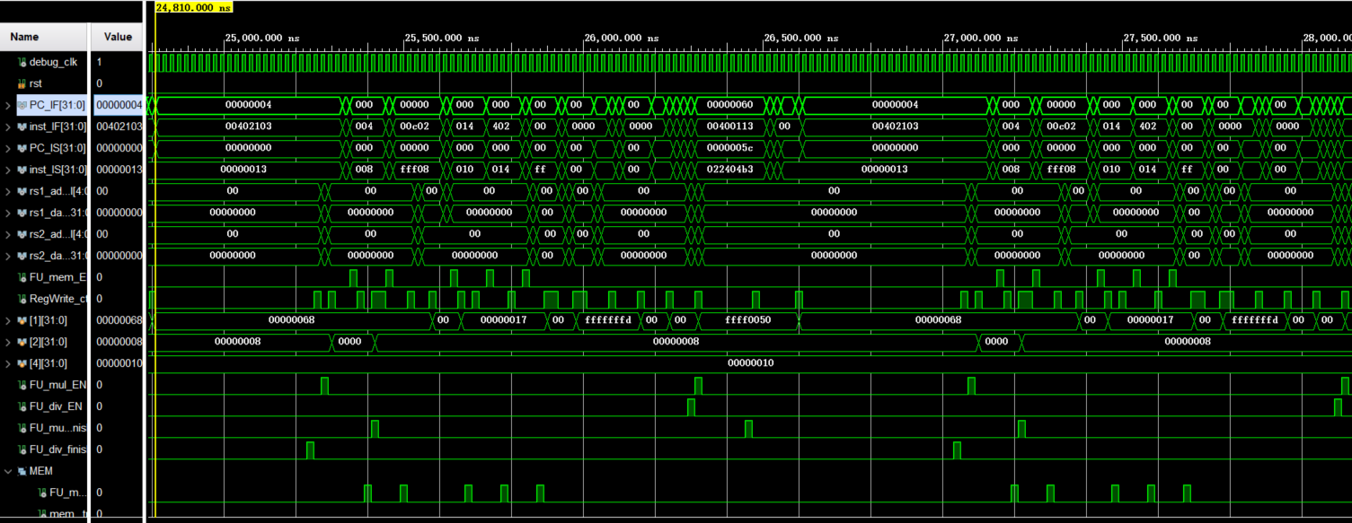

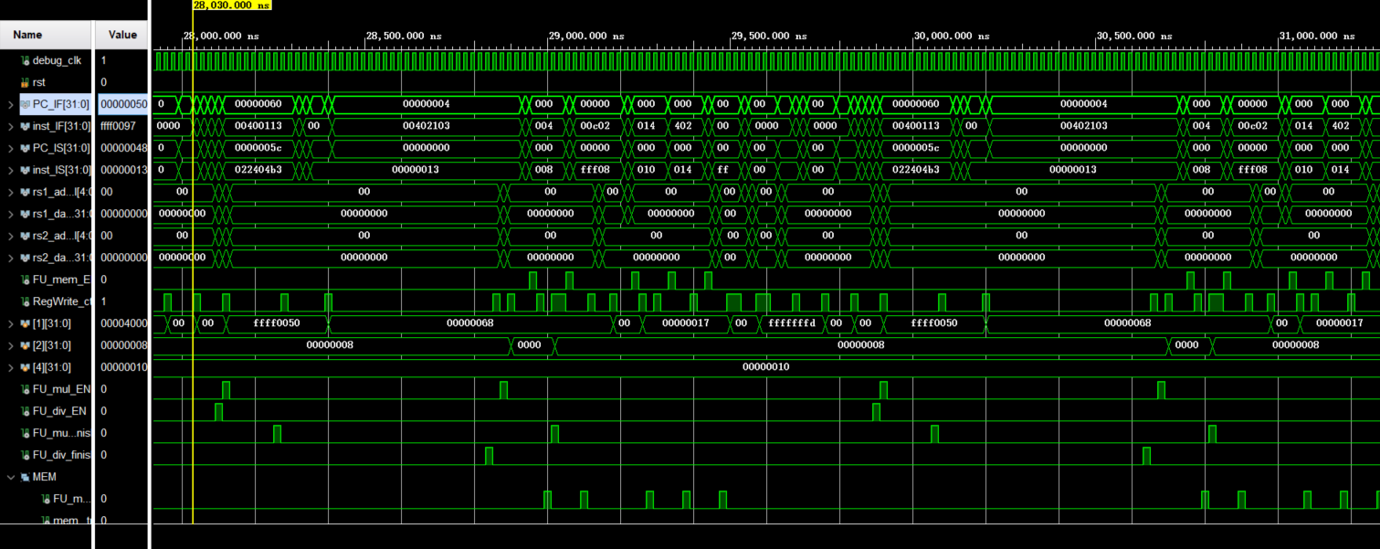

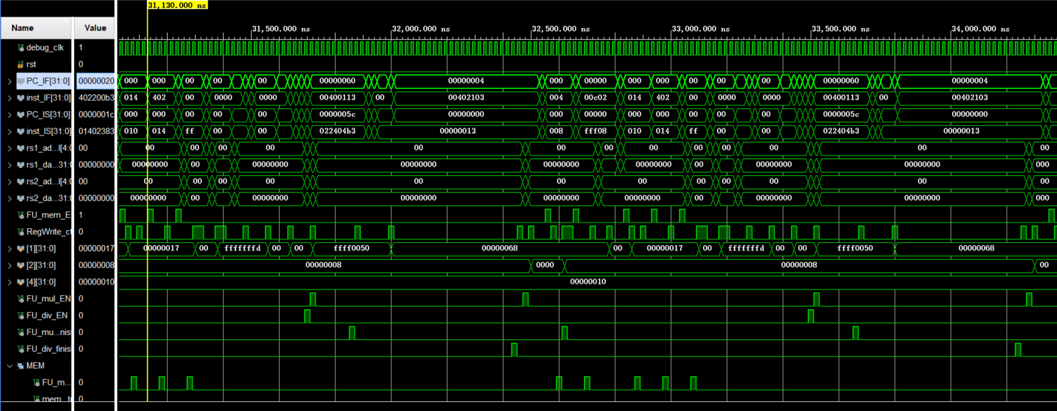

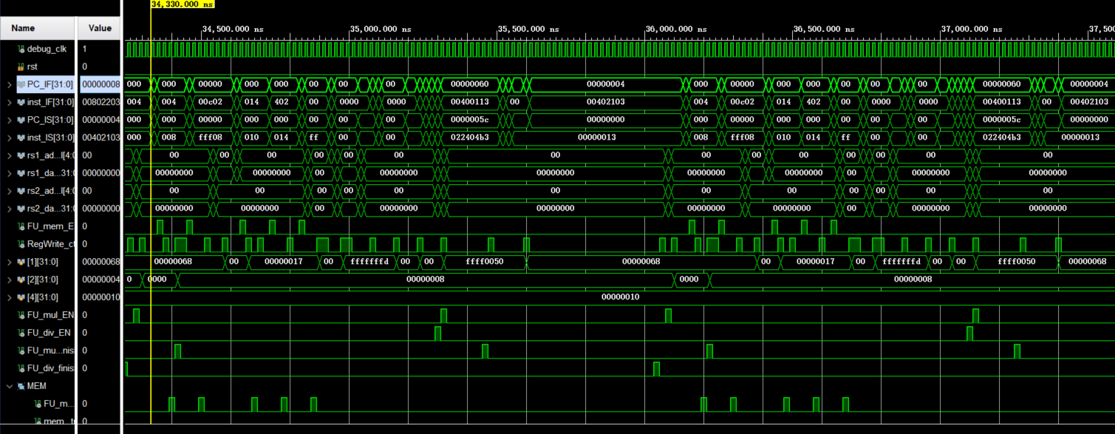

* 1. **Structural hazard**

Take the following three instructions as an example

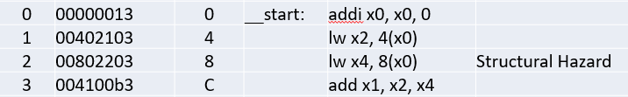

Due to the presence of only one Functional Unit for Memory (FU_MEM), a structural hazard arises. When the first instruction successfully writes to the register. Following this, the second instruction is issued between 9,700 ns and 10,100 ns.

As for the third instruction, it has no dependencies, so it is issued as anticipated from 10,100 ns to 10,500 ns. The subsequent information provides the on-board results of this scenario.

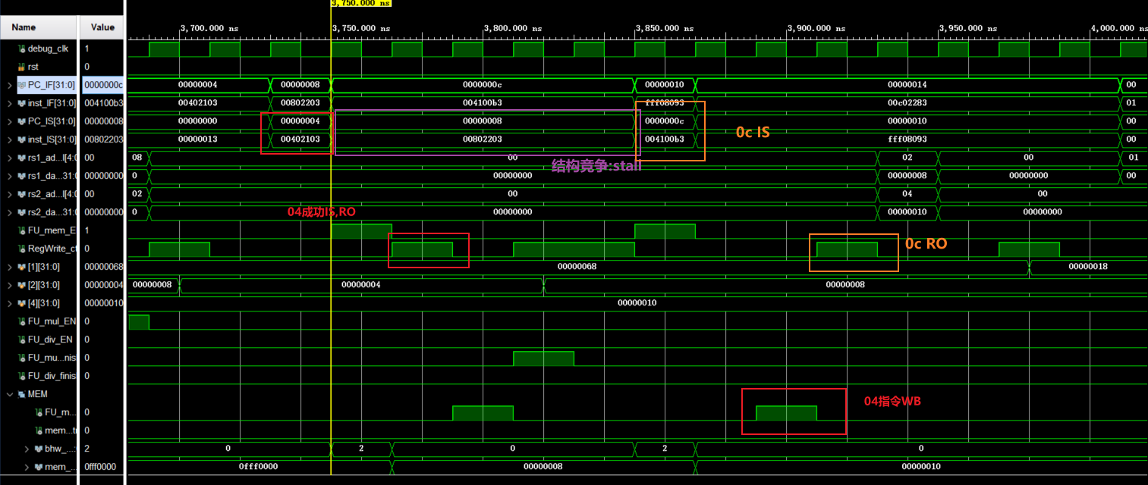

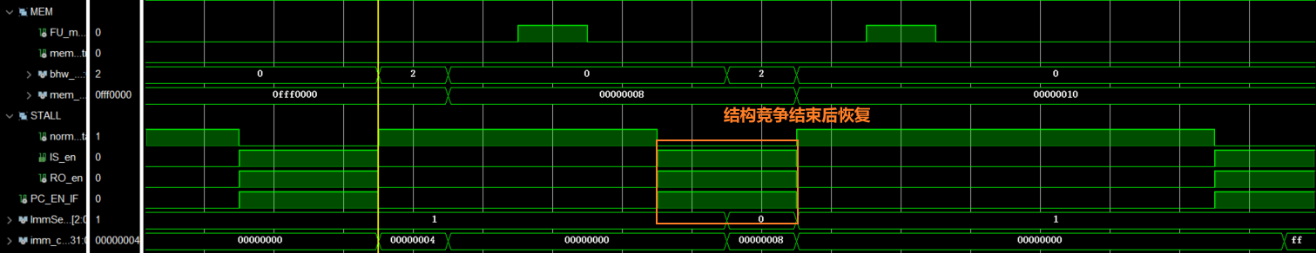

You can see that the final register value was successfully loaded

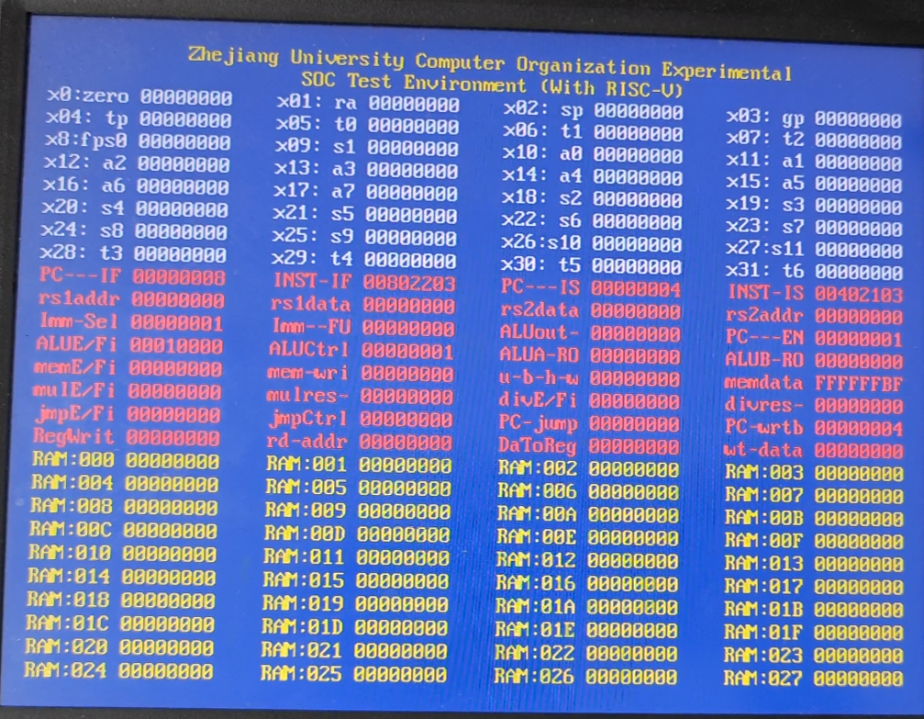

Before IS the first lw

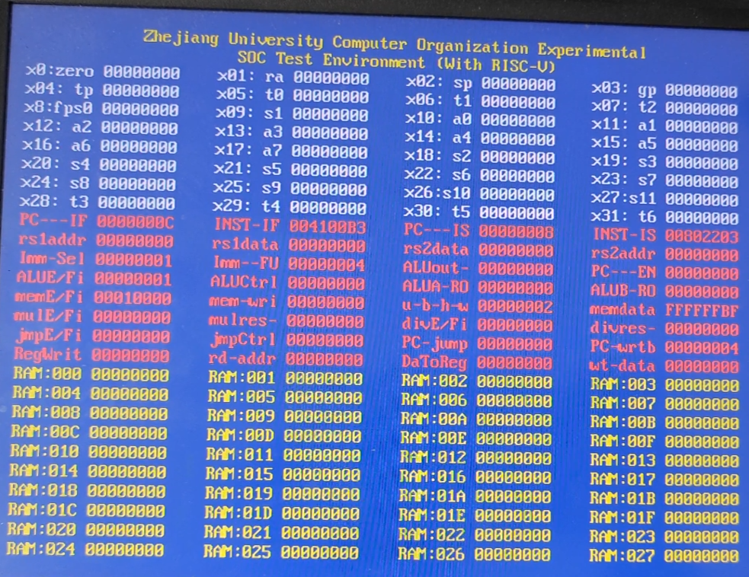

Issued, mem EN is set to 1.

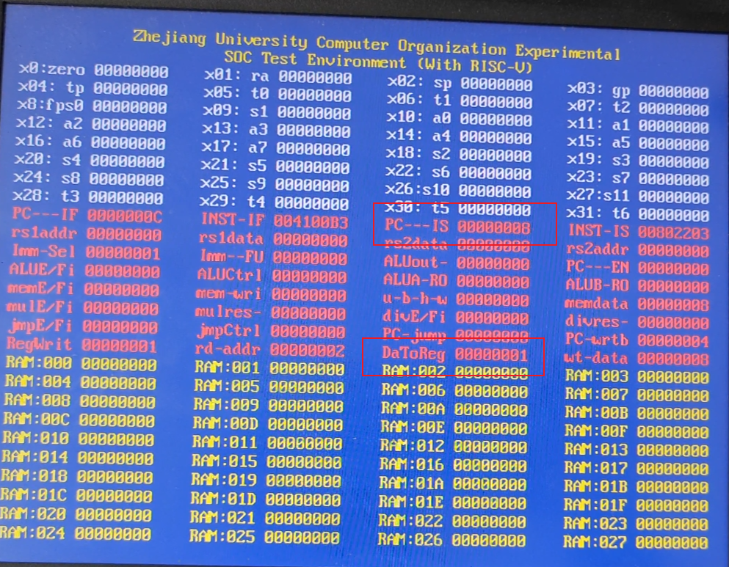

After 4 cycles, the instruction finished, and RegWrite -> 1.

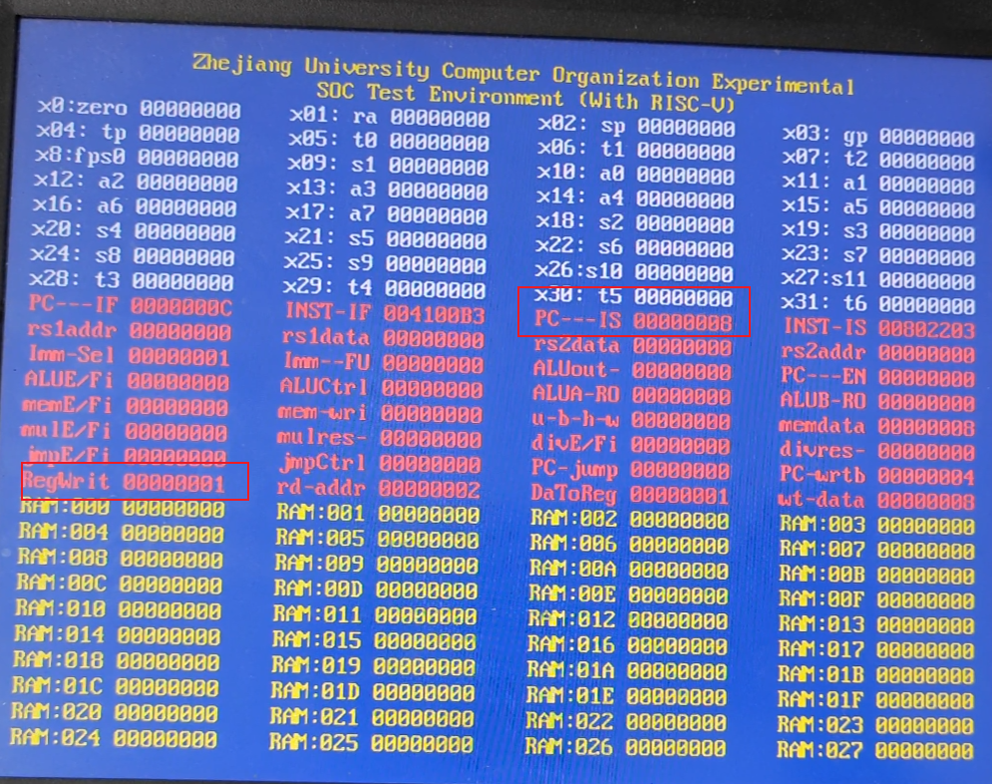

After another 1 cycle the next instruction was issued normally.

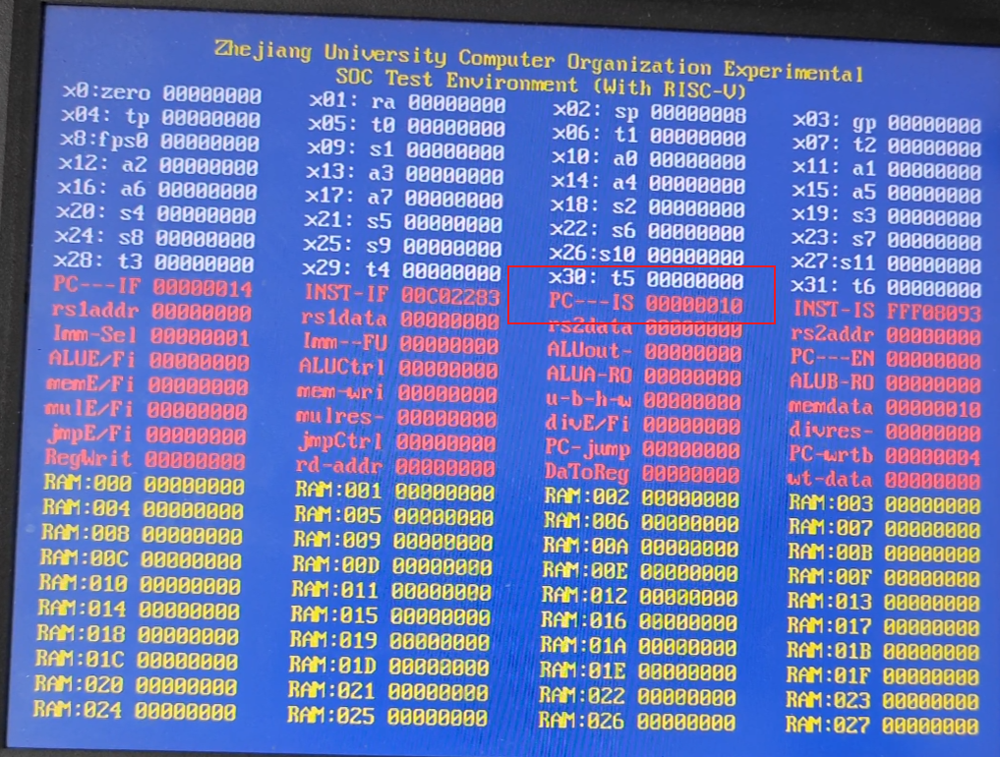

**WAW**

In the given set of instructions, there is a Read-After-Write (RAW) dependency between instruction 3 and instruction 1. Additionally, there is a Write-After-Write (WAW) dependency between instruction 4 and instruction 3.

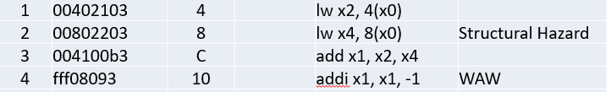

It's evident that even though instruction 3 completes its Instruction Stage (IS), it only performs the Read-Out (RO) operation after the results of instructions 1 and 2 have been written back (WB). Instruction 4 has been stalled, waiting for the result of instruction 3 to become available.

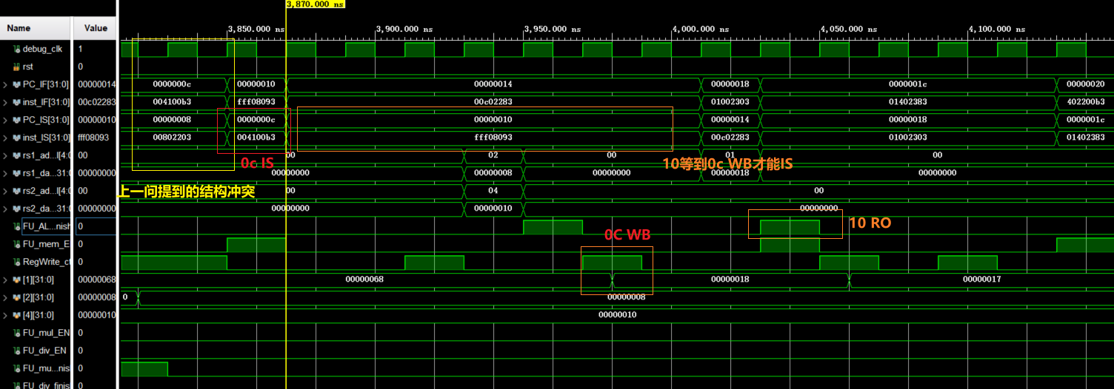

As anticipated, the results of instructions 3 and 4 have been successfully written back. The following are the on-board results:

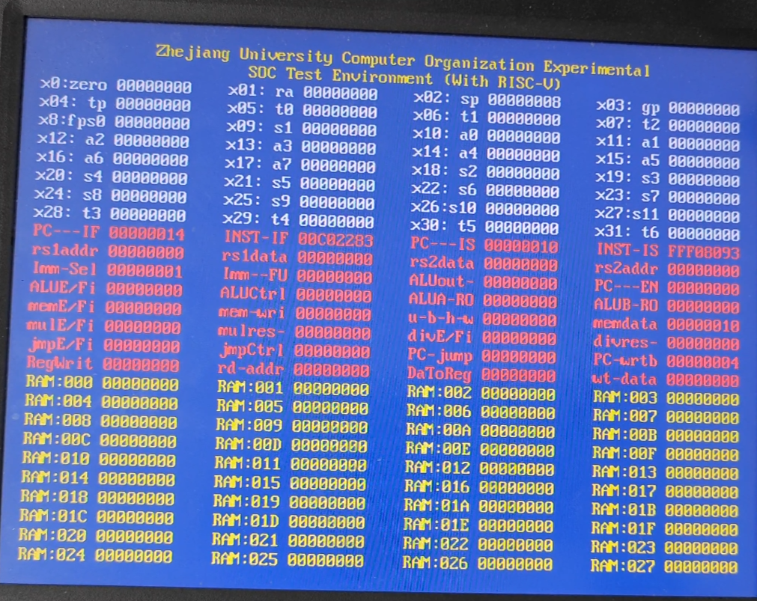

And the first add instruction issue

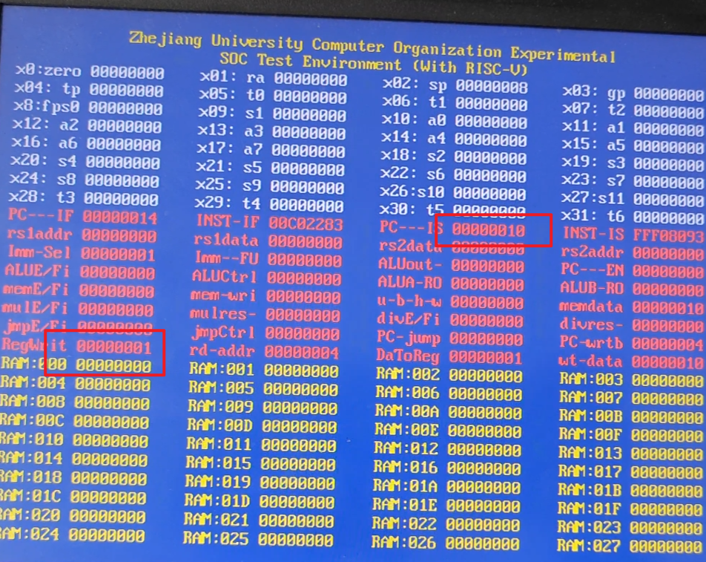

10 wait to be issued after some cycles after 0c is compeleted

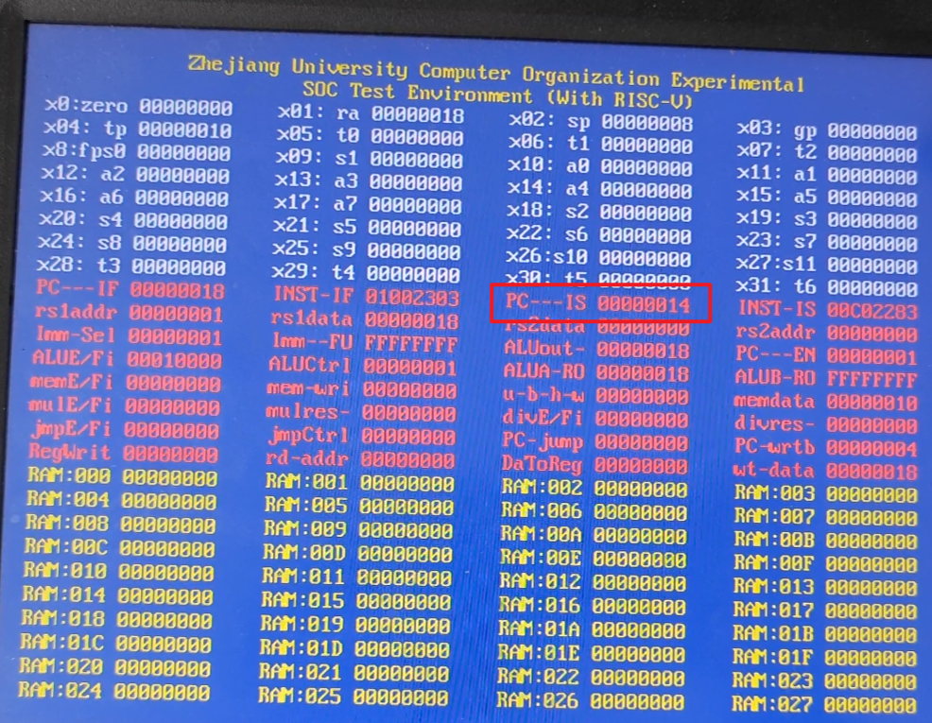

* 1. **Ctrl hazard**

Take the following instructions as an example

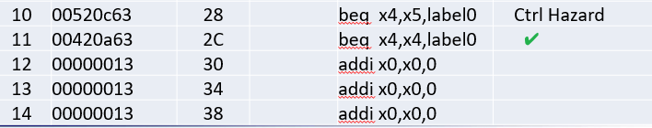

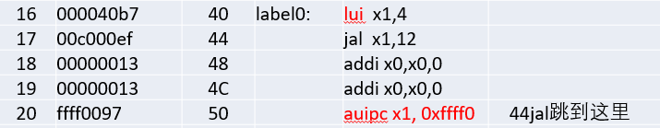

The first two consecutive "beq" instructions, the 10th and 11th, have a dependency. The 10th "beq" does not result in a jump, and the 11th "beq" instruction is waiting for the completion of the 10th "beq" before deciding whether to jump or not. This behavior is in line with expectations, as depicted in the figure above.

Now, let's examine the "jal" instruction that follows.

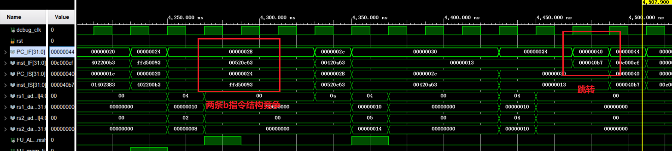

It is evident that the result of the "lui" instruction before the "jal" has been correctly written back, and the instructions after "jal" are not in the Instruction Stage (IS). Furthermore, "jal" has correctly executed the jump to the target position, aligning with the expected behavior.

* 1. **WAR hazard**

Take the following instructions as an example

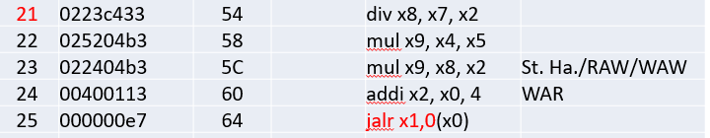

It's apparent that the fourth instruction could potentially create a Write After Read (WAR) hazard with the first instruction. Consequently, it must wait until the first instruction is completed.

However, it's noteworthy that the first instruction involves a division operation, which typically takes a significant number of cycles to complete. In this case, it finished its execution between 41,700 ns and 42,100 ns. Interestingly, the two multiplication operations were already completed by this time, indicating that out-of-order execution occurred in the processor.

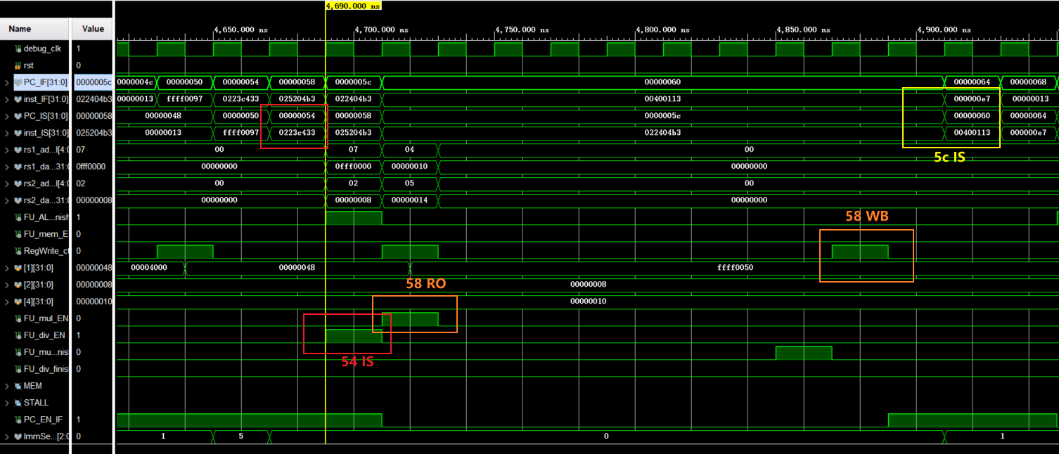

From the provided figure, it's apparent that instructions 21 and 22 are in the Instruction Stage (IS) successively. When instruction 22 completes its IS stage, instruction 23 also enters the IS stage. However, there is a dependency, as instruction 23 requires the calculation result of instruction 21. As a result, instruction 23 does not perform the Read-Out (RO) operation until it has the required data from instruction 21.

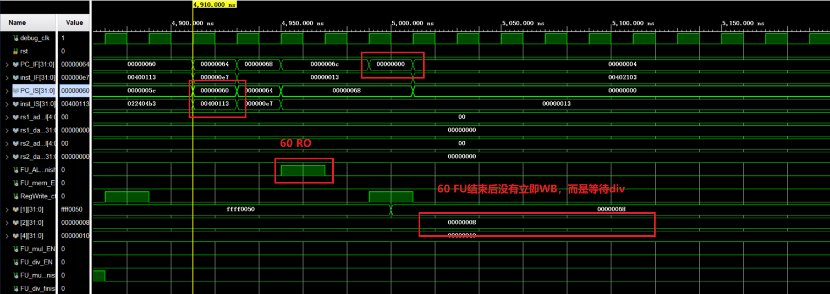

Following that, we can observe from the provided figure that the 24th instruction has entered the Instruction Stage (IS) and successfully completed the Read-Out (RO) and Functional Unit (FU) stages. However, since instruction 23 has not yet completed its RO stage and instruction 24 requires the value of x2 which is not yet available, instruction 24 cannot proceed to the Write-Back (WB) stage.

The following diagram shows the div command on the board.

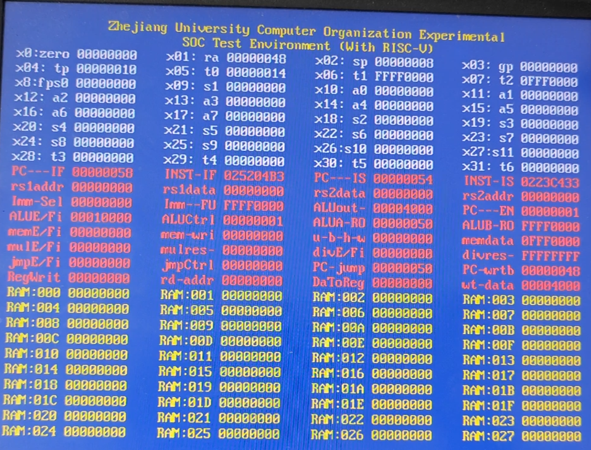

The first mul instruction IS

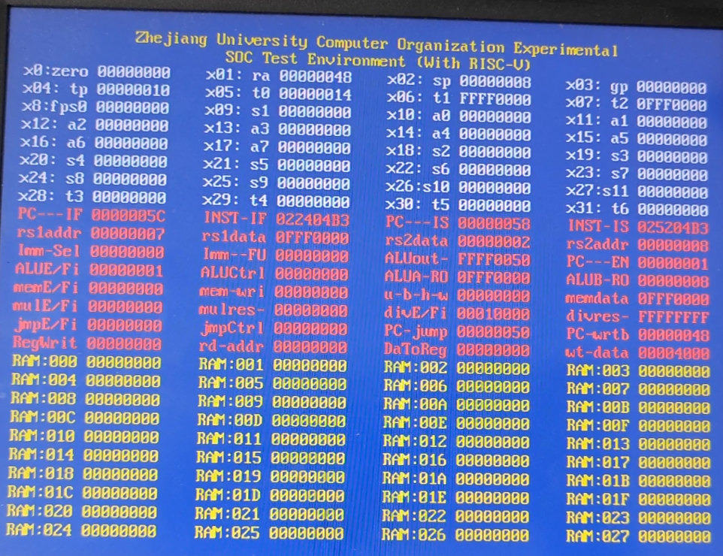

The first "mul" instruction writes to a critical register.

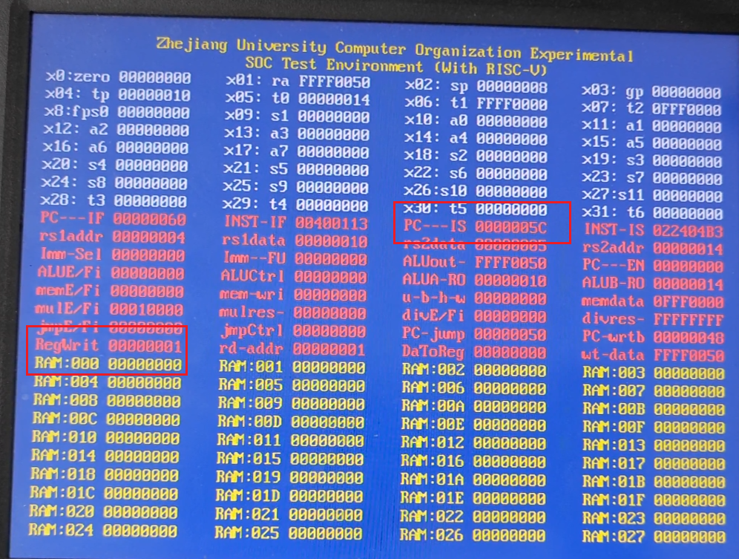

After some cycles …

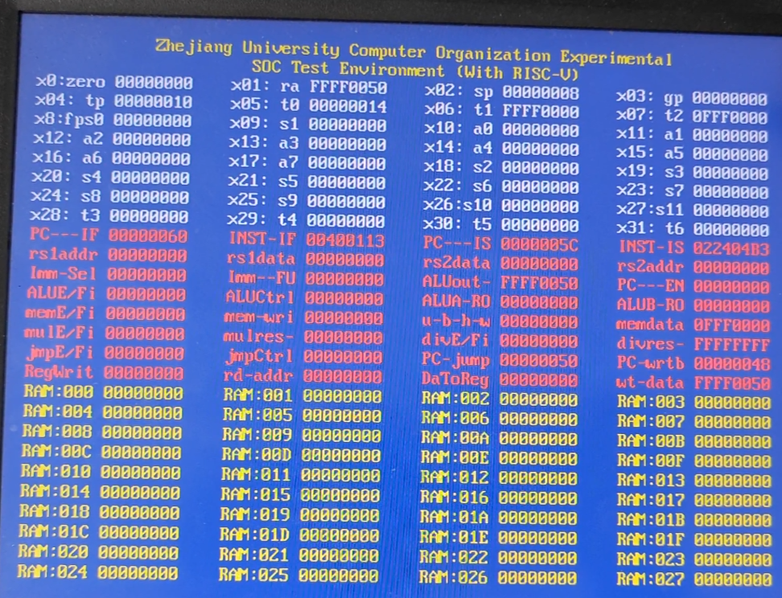

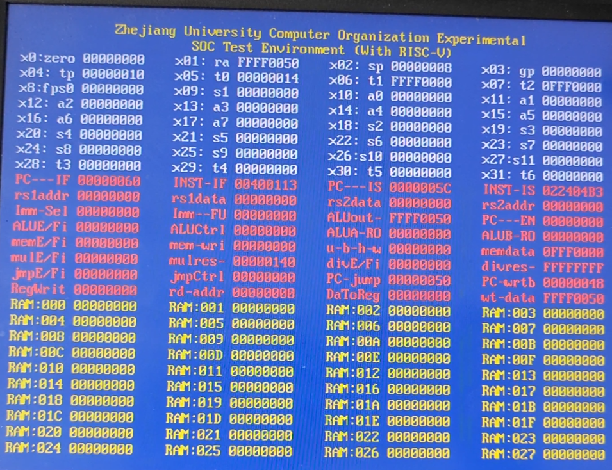

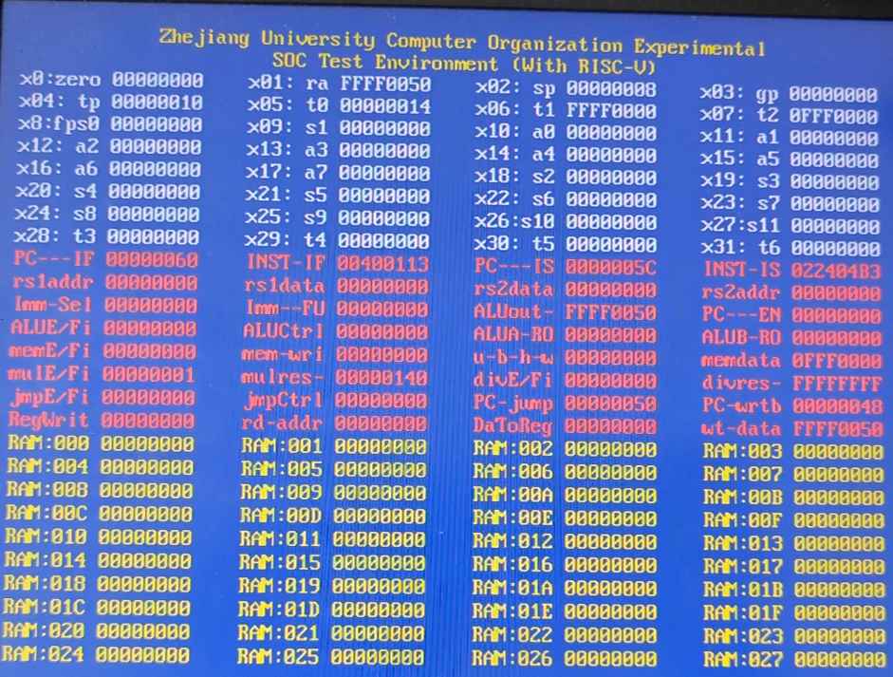

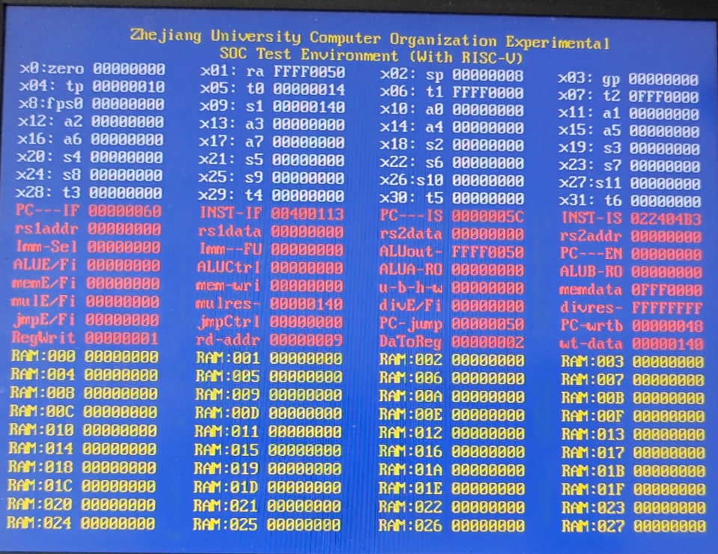

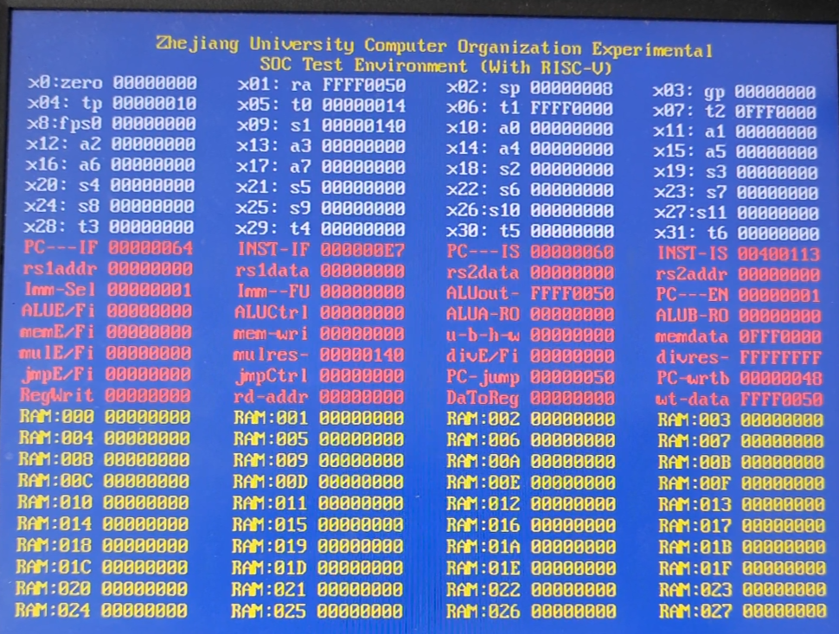

After 1 cycle the second mul issued.

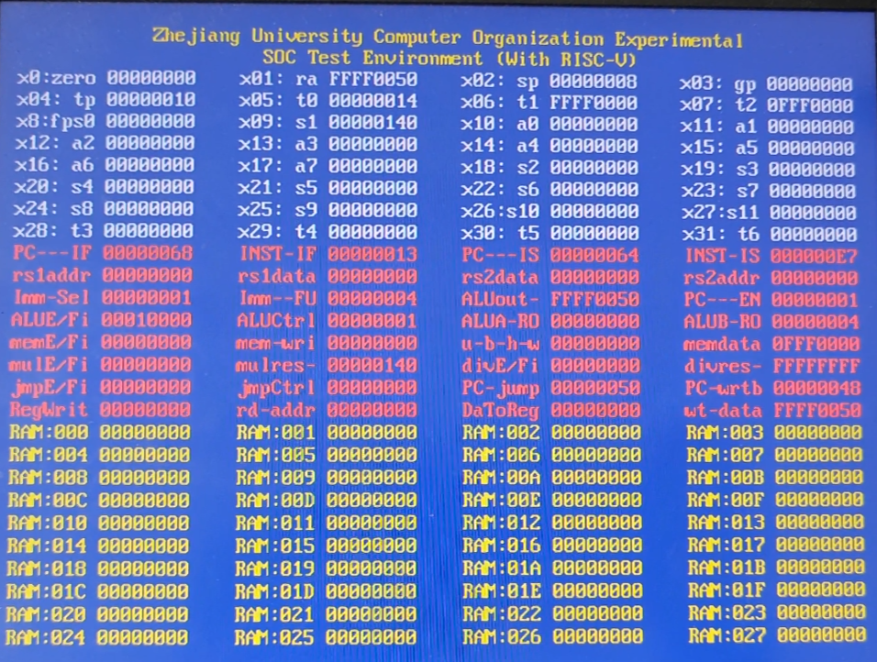

The "addi" instruction was issued because the arithmetic unit was not occupied at that time. However, after a significant number of cycles, the "div" instruction finally completed its execution.

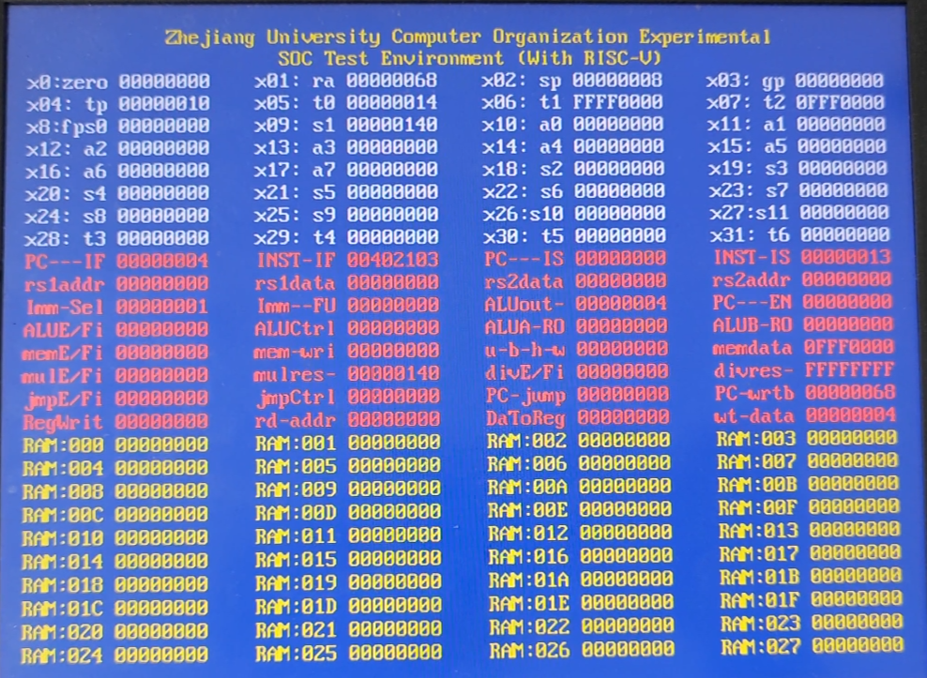

1. **Discussion and thoughts**

During this lab, I explored the scoreboard algorithm's implementation, a crucial aspect of architectural design. This experience provided valuable insights into dynamic scheduling in computer architecture, extending beyond theoretical concepts.

I encountered complexities, such as differentiating the FU_DONE bit in the Functional Unit Status (FUS) from pipelining registers in the Instruction Fetch (IF_IS) stage. This highlighted the intricacies of managing instruction execution in a complex architecture.

Despite the experiment's increased complexity than lab5, my strong grasp of the scoreboard algorithm proved instrumental. I successfully implemented a floating-point CPU for multicycle operations with scoreboard-based scheduling and refreshed my scoreboard theory knowledge.

In summary, this experiment was good, allowing practical application of scoreboard algorithm principles and enhancing my understanding of computer architecture and dynamic scheduling.